Christopher Morcom

CS 542

2 April 2019

**Assignment 2**

**How does Nyquist theory work in communication network systems and how do we use it to estimate communication capacities (give examples)? How does it work in a channel with a noisy environment?**

The Nyquist theorem states that a bandwidth *B* can be reconstructed if there are at least *2B* samples per second. Furthermore, this expands to state that the maximum data rate, or channel capacity of a link *in a noiseless channel* (in bits per second) is:

$R_{max}=2B\log_{2}{M}$ or $R_{max}=2Bn$

Where *M* is the number of signaling levels in a modulated digital signal, and n is the number of bits per encoded signal value. For example, if we had 8 signal levels in a modulated baseband signal for 4000Hz, $R_{max}=2\left(4000\right)\log_{2}{8}=2\left(4000\right)\left(3\right)=24000 bps$ where 8 signal levels are encoded with three bits.

This theorem expands to Shannon’s Law which accounts for noise in the channel where

$R_{max}=B\log_{2}\left(1+\frac{S}{N}\right) or R_{max}=B\log_{2}\left(1+SNR\right)$

where *S* is the signal power and *N* is the noise power. $\frac{S}{N}$ is denoted as *SNR* or signal-to noise ratio. For use of *SNR* in decibels, we use

${SNR}_{dB}=10\log_{10}{(SNR)}$ = S

For example, if *B* is 4kHz, and the transmission line has a quality of 40dB, then: $R_{max}=4000\log_{2}\left(1+10000\right)$ = 53.151 bps.

If we wanted to double the Capacity of the link, we would have to square $\left(1+\frac{S}{N}\right)$. In communication systems, this is important since noisy environments can hinder the reconstruction of a signal. For good approximation 10% is a reasonable oversampling factor since less may prove to be prohibitive in the signal reconstruction, but it can be reduced if low-complexity sampling is not crucial. Reconstruction is an *O(2N+1)* operation for each sample. If there are reconstruction errors or time skews (un-synced NICs), then an increase in Bandwidth can account for a low-order system.

**What is a MAC protocol in data link layer and why do we need it?**

Media Access Control (MAC) is a sublayer of the Data Link Layer in the OSI Model alongside the Link Layer Control (LLC). MAC Protocols are responsible for packet communication between Network Interface Cards (NICs). Each NIC has a unique MAC address. One major example of MAC in use is in Ethernet Networks. MAC solves collision errors in a shared network by acting as an interface between LLC and the Physical Layer to ensure fair transmission of data among the connected nodes on the channel and by frame synchronization. In terms of routing, MAC addresses only allow accurate communication for devices within the same network, while IP (Network Layer) allows intercommunication between networks. MAC addresses are stored at the Router to forward packets only to the specified NIC. MAC is also a secure way of regulating access control to a network since MAC Addresses are unique identifiers for each device. This also allows for DHCP servers to assign static IP addresses.

**Find various MAC protocols and their main characteristics, and how they work.**

*Random Access Protocols* allow stations to not give priority to any nodes that it is connected to. The main features include no fixed time for data transmission, nor a fixed sequence for stations sending data. Examples are below:

* ALOHA: designed for WLAN to allow multiple stations to send data in a first-come-first-served basis, but results in many collisions, where packets are retried within a back-off-time (Tb), which results in a timeout if no ACK is received in Tb. Slotted ALOHA divides time into slots and works like Pure ALOHA.
* CSMA: Senses the medium for idle or busy status before transmission data, but may result in collisions due to propagation delay

*Controlled Access Protocols* require the network stations to seek information from on another, allowing only one node to send data at a time, preventing collisions on a shared medium. Examples are below:

* Reservation: stations reserve a fixed interval of time or a period of frames to send data in order.
* Polling: a single node acts as the controller for the other stations to grant data transmission or send a N-ACK message on denial.
* Token Passing: stations are connected in a Bus ring topology where a token is circulated across N stations in a predefined order.

*Channelization Protocols:*

* FDMA: bandwidth is divided into equal bands to allocate a band for each system.
* TDMA: time is slotted for each station to transmit data periodically using the entire bandwidth of the channel.
* CDMA: One channel carries all messages but “modulates” the data between each pair of communicating devices by transmitting data in different code languages.

**Study ARQ of data link layer. What are them and how each works with example diagram. Especially research in detail of Go Back N and Selective Repeat of the ARQ to understand TCP’s concept.**

Sliding Window Protocols are error control protocols that retransmit damaged or lost frames. In TCP, *Go-Back-N* and *Selective Repeat* are protocols that require ACK packets to be received for each transmitted packet.

In *Go-Back-N*, packets are sent to a receiver. On receipt, the receiver sends an ACK for each frame (identified by sequence number (seqno.)). If an ACK is lost, the sender will send all *N* packets starting from the unacknowledged seqno. after a timeout period *T*. Similarly, retransmission of *N* packets on receipt of an NAK or negative acknowledgement packet from the receiver for a lost or damaged packet. Any frames after the NAK seqno. Are discarded if already received.

In *Selective Repeat*, only the lost packet is retransmitted since the receiver is capable of sorting packets (by seqno.), however, the sender and receiver have to have a buffer capable of storing the non-ACKed packets, or packets waiting to be processed due to a retransmission and sort. This method is superior to *Go-Back-N* in that it requires a smaller window size. For damaged frames, a NAK is sent and the receiver waits for a retransmission, while not ACKing any other frames in the meantime. For lost frames, the receiver will send a NAK for a missing seqno. corresponding to the lost frame and waits for retransmission. If the last frame is not ACKed, then the sender will retransmit. Lost ACKs require a timeout period *T* where the sender will retransmit all frames from the non-ACKed frame. Duplicate frames are discarded by the sender.

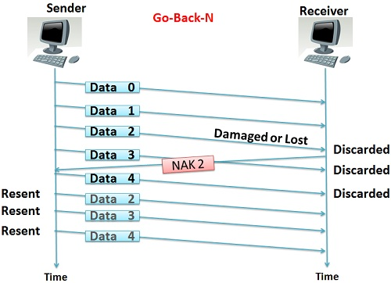

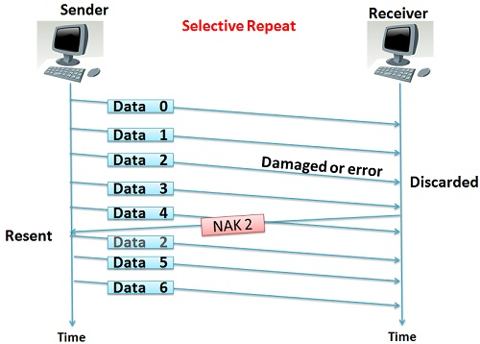

**Describe Cyclic Redundancy Check (CRC) error control of the data link layer.**

CRC works on links where retransmission is more efficient than rebuilding the raw data that is sent, but corrupted. CRC works by taking a block of data moving to the Data Link Layer with a short Check Value (CV) related to the division of its content. A divisor is selected through agreement between client and host. The remainder of the quotient is the CV and is appended to the raw data being sent. The receiver takes the divisor and divides the block with appended CRC and divides. If the remainder is zero, then there is no error. Else, retransmission is requested.

For example, if we have a divisor 5 and a block of data, 127, our CRC would be 2. Our Data+CRC = 510, which is divisible by 5 with a remainder of zero, so our data checks out.

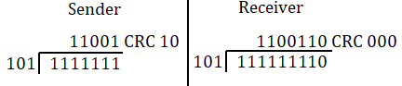

**What are relations and differences between Data transfer speed (R) and signaling rate (Rs). Describe them with examples.**

*Data Transfer Speed (Data Rate)*

* Number of binary bits transferred per second (denoted as R, in units of bits/sec)
* Sometimes denoted as the Data Rate or Bit Rate.
* Efficiency of the link increases with Data Rate

*Signaling Rate (Baud Rate):*

* Number of signals per second that carry *N* bits per signal (denoted as Rs in units of Baud)
* Efficiency of the link *decreases* with signaling rate.

Data Rate and Baud Rate are related in the formula below:

$R_{s}=\frac{N}{r}$ where $r=\log_{2}{L}=\frac{N}{S}$

Where *R­s* is the Baud rate, *N* is the Data Rate, *r* is the bits per Baud or data elements per signal element, and *L* is the number of signal elements.

For example, if we have a baseband analog signal of bit rate 24 kbps with a limit of 32 signal elements, then:

$$r=\log_{2}{(32)}=5 bits/Baud$$

$$R_{s}=\frac{24000}{5}=4800 Baud$$

So to accommodate this channel, we need 4800 signals/sec or a channel with a rating of 4800 Baud.

**Works Cited**

J. D. Broesch, D. Stranneby, and W. Walker, *Digital signal processing: instant access*. Amsterdam: Newnes/Elsevier, 2009.

“Computer Network | Controlled Access Protocols,” *GeeksforGeeks*, 05-Apr-2018. [Online]. Available: https://www.geeksforgeeks.org/computer-network-controlled-access-protocols/. [Accessed: 03-Apr-2019].

“Difference Between Go-Back-N and Selective Repeat Protocol,” *Tech Differences*, 20-May-2016. [Online]. Available: https://techdifferences.com/difference-between-go-back-n-and-selective-repeat-protocol.html. [Accessed: 02-Apr-2019].

J. Fitzpatrick, “What Exactly Is a MAC Address Used For?,” *How-To-Geek*, 04-Sep-2013. [Online]. Available: https://www.howtogeek.com/169540/what-exactly-is-a-mac-address-used-for/. [Accessed: 03-Apr-2019].

L. Frenzel, “What's The Difference Between Bit Rate And Baud Rate?,” *Electronic Design*, 04-May-2018. [Online]. Available: https://www.electronicdesign.com/communications/what-s-difference-between-bit-rate-and-baud-rate. [Accessed: 03-Apr-2019].

N. Libreman, “What is cyclic redundancy check and how it works in simple terms (for-dummies style)?,” *Stack Overflow*, 12-Mar-2012. [Online]. Available: https://stackoverflow.com/questions/9635561/what-is-cyclic-redundancy-check-and-how-it-works-in-simple-terms-for-dummies-st. [Accessed: 03-Apr-2019].